Project 3 Final Report – BIOS 6624
1 Introduction
The data for this analysis were provided by the Framingham Heart Study, one of the first prospective studies of cardiovascular disease. The study followed subjects living in Framingham, Massachusetts, over the course of 24 years collecting data during repeated visits on known cardiovascular disease risk factors and markers. The primary analysis of this report will focus on the 10-year probability of stroke for various risk profiles of interest to the investigator. Additionally, a secondary analysis will be conducted to examine the changes in certain risk factors over time to assess the necessity of a time-varying covariate analysis in the future.
2 Methods
2.1 Data Cleaning
Prior to any analysis, 32 participants were excluded due to reporting a stroke at their baseline visit, as these events occurred prior to the start of the study period. As this analysis focused on baseline predictors of stroke, only observations from participants’ baseline visits were retained for the analysis.
A 10-year follow-up window was applied to all participants. The outcome of interest, stroke-free survival, was defined using two derived variables. The event indicator was coded as 1 if a stroke occurred within 10 years of baseline and prior to death, and 0 otherwise. The survival time variable was constructed as follows: if a stroke occurred within 10 years and prior to death, survival time was set to the time of stroke; if a participant died within 10 years without a prior stroke, survival time was set to the time of death; if neither event occurred within 10 years, the participant was right-censored at 3652.5 days.
2.2 Variable Selection
All predictors were measured at participants’ baseline visit. The investigator specified systolic blood pressure, presence of diabetes, and age as required predictors in all models. Additional covariates considered for inclusion were BMI, prevalent coronary heart disease, use of blood pressure medication, current smoking status, and total cholesterol. To ensure a consistent sample during variable selection, complete case analysis was first performed across all eight candidate variables. Backward selection using the Akaike Information Criterion (AIC) was then conducted separately for males and females, with systolic blood pressure, diabetes, and age forced into each model. Following variable selection, complete case analysis was repeated using only the final selected variables to maximize sample size for model fitting.
2.3 Statistical Analysis
Kaplan-Meier curves were produced for each covariate separately for males and females to visually assess associations with stroke-free survival prior to modeling. Cox proportional hazards models were then fit separately for males and females using the variables identified through the selection process described above. The proportional hazards assumptions were assessed for each final model using Schoenfeld residual tests and plots. Hazard ratios and 95% confidence intervals were calculated and reported. To further characterize stroke risk, 10-year stroke-free survival probabilities were estimated for five risk profiles of interest at ages 40, 50, and 60 for both males and females. For the secondary analysis, systolic blood pressure and diabetes status were examined descriptively across three time periods to assess whether these risk factors changed over time, stratified by sex.
3 Results
Following the application of exclusion criteria, 4,402 individual participants were included in the analysis, composed of 1,930 males and 2,472 females. Participant characteristics are summarized in Table 1. Approximately 2.5% of participants experienced a stroke within 10 years of their baseline visit. Males were more likely to have prevalent coronary heart disease, less likely to be taking blood pressure medication, and more likely to be current smokers compared to females. Both sexes had similar mean systolic blood pressure, age, total cholesterol and BMI. The extent of missingness across all covariates is reported in Table 1 as well.
Table 1. Summary Statistics of Framingham Participants at Baseline Visits.
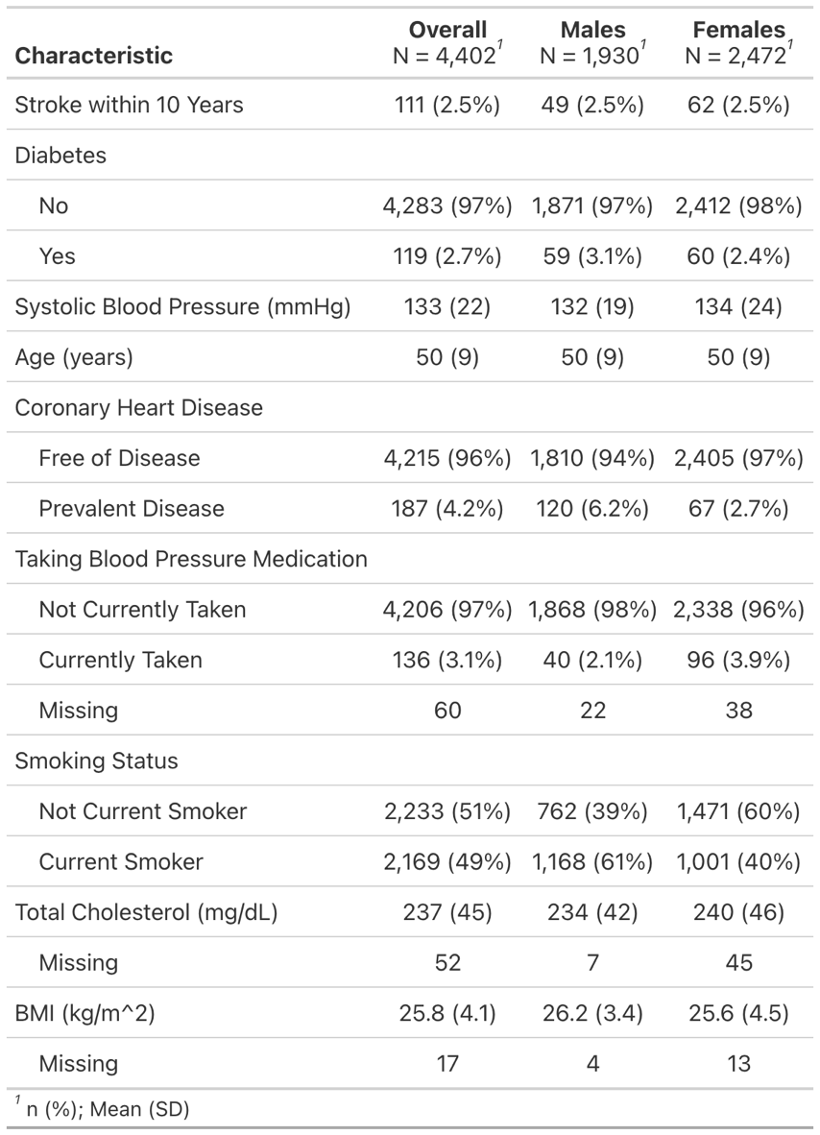
3.1 Ten-Year Survival Probability
3.1.1 Kaplan-Meier Curves
Kaplan-Meier curves stratified by each covariate are presented in Figures 1 and 2 for females and males respectively. In both sexes, clear separation between survival curves was observed for age, systolic blood pressure, diabetes status, and blood pressure medication use, with higher risk groups consistently showing lower stroke-free survival over the 10-year follow-up period. Prevalent coronary heart disease also showed notable separation in both sexes, though the high-risk group was small as illustrated by the wide confidence intervals. Smoking showed modest separation while total cholesterol and BMI showed minimal separation between groups in both sexes, suggesting limited association with stroke-free survival when dichotomized at the mean.
Figure 1. Kaplan-Meier Curves by Covariate for Female Participants
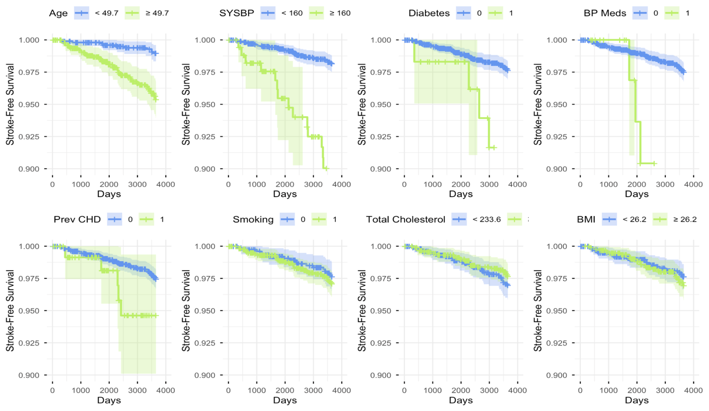
Figure 2. Kaplan-Meier Curves by Covariate for Male Participants
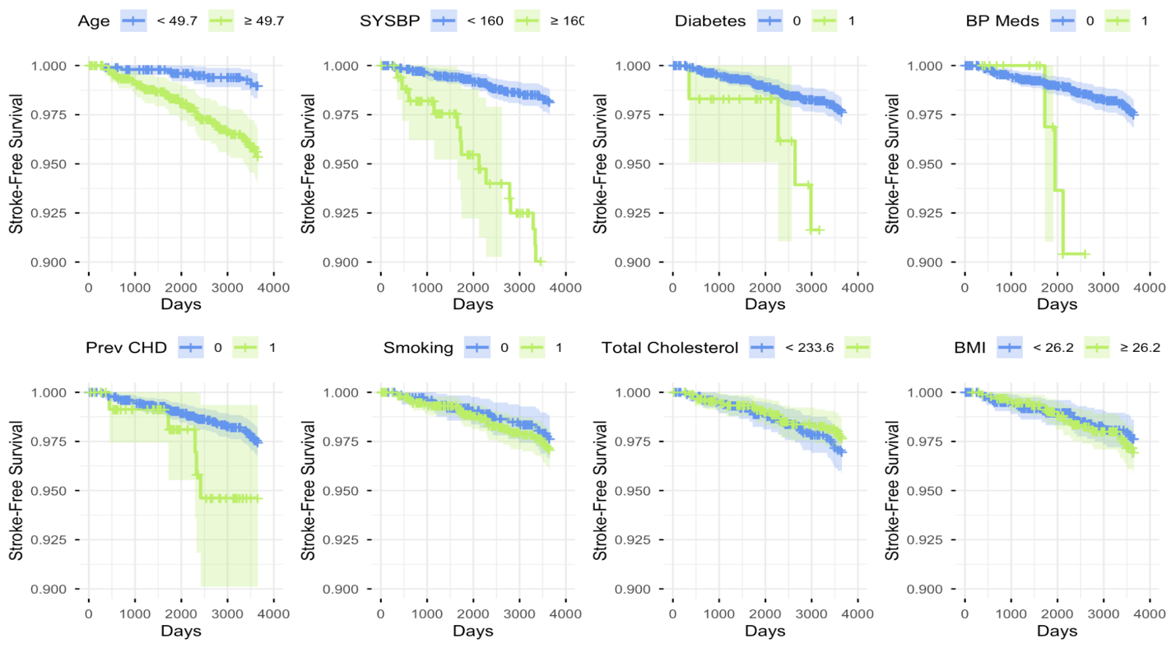
3.1.2 Variable Selection and Model Results
Backward AIC selection retained age, systolic blood pressure, and diabetes as predictors in the female model. For males, current smoking status was additionally retained. Although backward AIC selection did not retain current smoking status in the female model, the difference in AIC was minimal and the variable was retained to allow for direct comparison between sexes.
The proportional hazards assumption was assessed for each final model using Schoenfeld residuals and was satisfied for all covariates (plots are provided in the appendix). Estimated hazard ratios and 95% confidence intervals for both models are presented in Table 2. In the female model, age and systolic blood pressure were statistically significant predictors of stroke (p < 0.001). Each additional year of age was associated with a 6.8% increase in stroke hazard (HR = 1.068, 95% CI: 1.030, 1.109), and each 1 mmHg increase in systolic blood pressure was associated with a 2.9% increase in stroke hazard (HR = 1.029, 95% CI: 1.021, 1.037). Diabetes status and current smoking status were not statistically significant in females (p = 0.368 and p = 0.322 respectively), though both were associated with increased hazard in the expected direction. In the male model, all four predictors were statistically significant. Each additional year of age was associated with a 7.0% increase in stroke hazard (HR = 1.070, 95% CI: 1.031, 1.110), and each 1 mmHg increase in systolic blood pressure was associated with a 3.2% increase in stroke hazard (HR = 1.032, 95% CI: 1.021, 1.043). Diabetes was associated with a 4.3-fold increase in stroke hazard among males (HR = 4.287, 95% CI: 1.862, 9.873), a notably stronger effect than observed in females (HR = 1.597, 95% CI: 0.576, 4.429). Current smoking status was associated with approximately twice the hazard of stroke compared to non-smokers in males (HR = 2.013, 95% CI: 1.084, 3.738).
Table 2. Cox Proportional Hazards Model Results for Females and Males
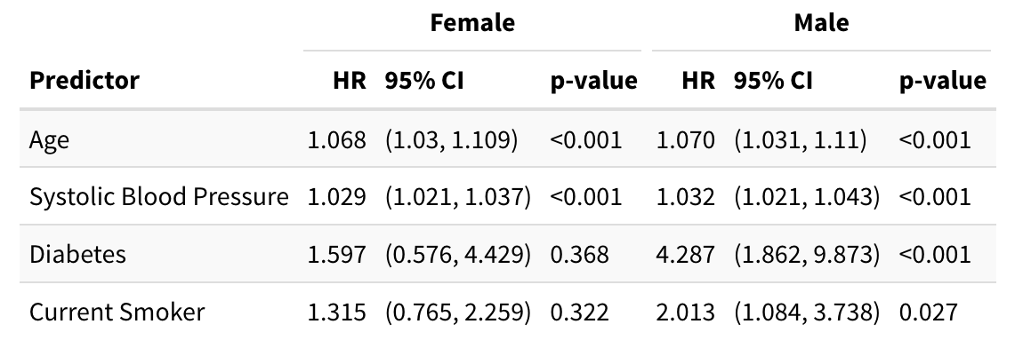
3.1.3 Risk Profiles
Ten-year stroke-free survival probabilities for five risk profiles at ages 40, 50, and 60 are presented in Table 3 for both sexes. Across all profiles and ages, survival probabilities remained high, reflecting the relatively low overall stroke incidence in this cohort. Among females, the combined high systolic blood pressure and diabetes profile showed the greatest reduction in stroke-free survival, with a 60-year-old female in this profile having a 91.9% probability of remaining stroke-free compared to 98.7% for a healthy 60-year-old female. A similar pattern was observed in males, where the combined high systolic blood pressure and diabetes profile showed the most pronounced reduction in stroke-free survival, with a 60-year-old male having an 80.3% probability of remaining stroke-free — notably lower than the corresponding female probability of 91.9%. Across all profiles, older age was consistently associated with lower stroke-free survival, and males in the high-risk combined profile showed substantially lower survival probabilities than their female counterparts.
Table 3. 10-Year Stroke-Free Survival Probabilities by Risk Profile
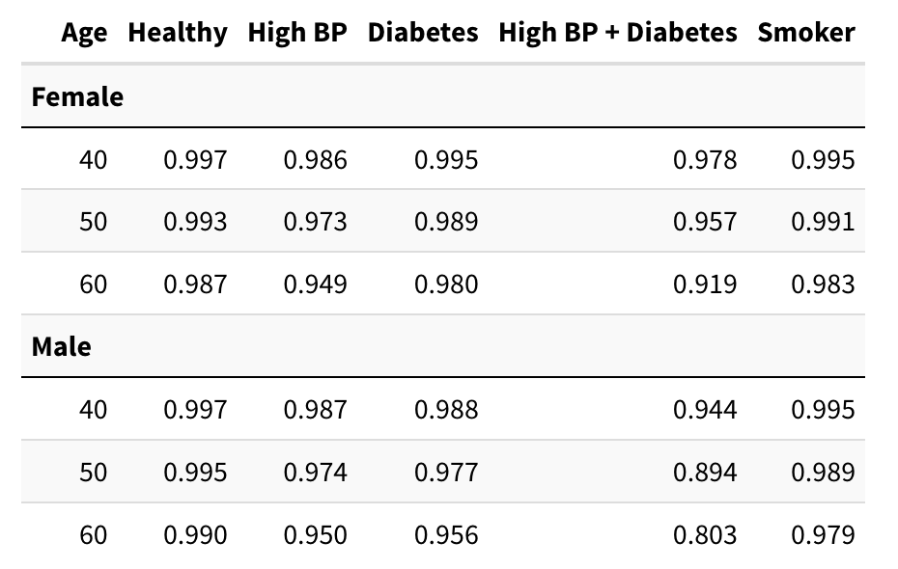
3.2 Assessment of Time Variation
To assess whether systolic blood pressure and diabetes status varied meaningfully over time, both variables were examined descriptively across three study periods, stratified by sex (Table X). Mean systolic blood pressure increased across periods for both sexes, rising from 131.7 mmHg (SD = 19.4) to 139.3 mmHg (SD = 21.2) in females and from 133.8 mmHg (SD = 24.5) to 140.9 mmHg (SD = 24.1) in males. Diabetes prevalence more than doubled across periods in both sexes. At the individual level, 69.5% of participants experienced a clinically meaningful change in systolic blood pressure (≥10 mmHg), exceeding the 10% threshold, while only 4.9% experienced a change in diabetes status, falling below it. Given the substantial individual-level variation in systolic blood pressure, a time-varying covariate model is recommended for future analyses to more accurately capture its dynamic influence on stroke risk over the follow-up period.
Table 4. Systolic Blood Pressure and Diabetes Status Across Time Periods by Sex
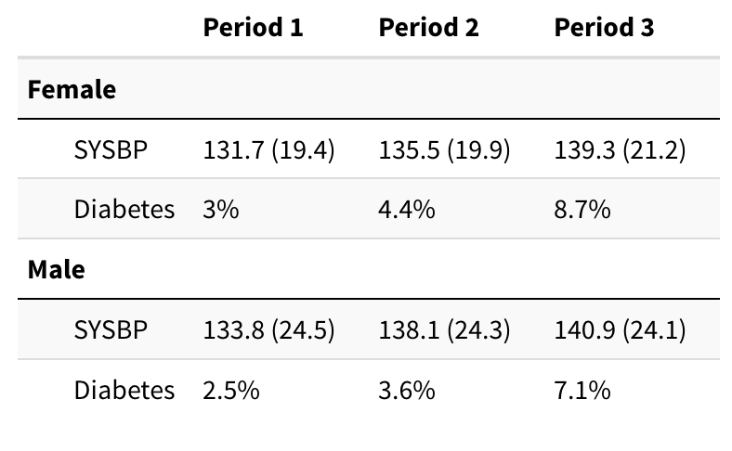
4 Discussion
This analysis examined 10-year stroke-free survival among 4,402 Framingham Heart Study participants using Cox proportional hazards models fit separately for males and females. Age and systolic blood pressure were significant predictors of stroke in both sexes, consistent with established cardiovascular disease literature. The most notable finding was the substantially stronger effect of diabetes in males (HR = 4.287) compared to females (HR = 1.597), which was not statistically significant, potentially reflecting true biological differences or limited statistical power given the relatively small number of events. Current smoking was a significant predictor only in males, which is consistent with findings in the broader literature. The risk profile analysis highlighted that the combined presence of hypertension and diabetes produced the greatest reductions in stroke-free survival, particularly among older males.
Several limitations should be noted. Complete case analysis assumes data are missing completely at random, which cannot be verified. All predictors were measured at baseline only, which as demonstrated by the secondary analysis, may not adequately capture dynamic changes over follow-up. Interaction terms between predictors were not considered, and future analyses should explore whether the combined effect of risk factors differs from their individual effects. Finally, the Framingham cohort's limited demographic diversity may restrict generalizability.
5 Reproducible Research
All data files and analysis code relevant to this project and final report are available at: https://github.com/mmschina/BIOS6624. All code can be found within the folder titled Project3/Code/, where there are separate scripts for data cleaning and analysis. The original dataset can be found under Project3/Data/frmgham2.csv on the local drive, specifically: /Users/Madelynn/Documents/Spring 2026 Courses/Advanced Statistical Methods - BIOS 6624/BIOS6624/Project 3/Data/frmgham2.csv
6 Appendix
The following section contains additional figures and tables from the analysis to clarify any potential questions.
Figure 3. Schoenfeld Residual Plots for Female Cox Proportional Hazards Model
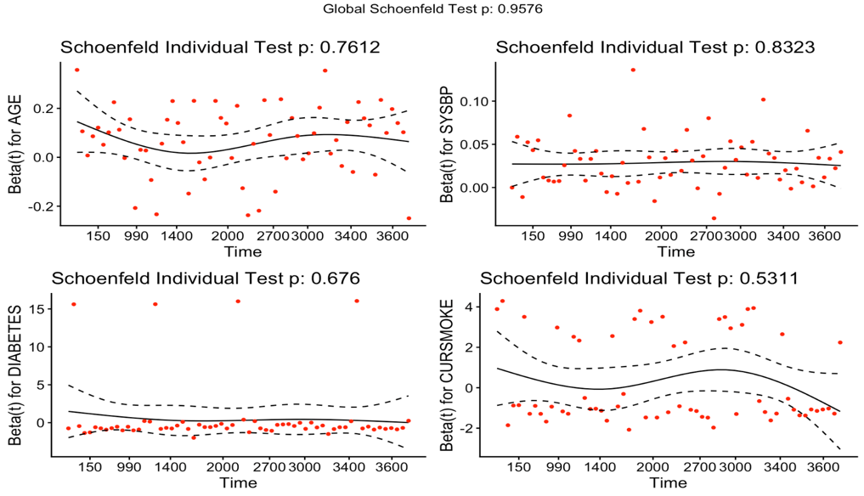
Figure 4. Schoenfeld Residual Plots for Male Cox Proportional Hazards Model
